Case Study
Jennifer, the owner and manager of a company with ten employees, has hired you to take over the HRM function so she can focus on other areas of her business. During your first two weeks, you find out that the company has been greatly affected by the up economy and is expected to experience overall revenue growth by 10 percent over the next three years, with some quarters seeing growth as high as 30 percent. However, five of the ten workers are expected to retire within three years. These workers have been with the organization since the beginning and provide a unique historical perspective of the company. The other five workers are of diverse ages.
In addition to these changes, Jennifer believes they may be able to save costs by allowing employees to telecommute one to two days per week. She has some concerns about productivity if she allows employees to work from home. Despite these concerns, Jennifer has even considered closing down the physical office and making her company a virtual organization, but she wonders how such a major change will affect the ability to communicate and worker motivation.
Jennifer shares with you her thoughts about the costs of health care on the organization. She has considered cutting benefits entirely and having her employees work for her on a contract basis, instead of being full-time employees. She isn’t sure if this would be a good choice.
Jennifer schedules a meeting with you to discuss some of her thoughts. To prepare for the meeting, you perform research so you can impress your new boss with recommendations on the challenges presented.
To better manage these challenges, you propose creating a Resource Breakdown Structure (RBS) to identify all resources and their roles. You also suggest a RACI Chart to clarify responsibilities for key tasks.
- Create a Resource Breakdown Structure (RBS):
  - Break down resources for the following:
    - Telecommuting setup.
- Draw a RACI Chart:
  - Assign roles and responsibilities for:
    - Assessing and procuring necessary technology tools.

Resource Breakdown Structure (RBS):
The RBS is a hierarchical framework used to organize and categorize resources required for a project. It breaks down resources into manageable components and groups them based on their type, such as personnel, equipment, materials, and facilities. This tool helps in resource planning, allocation, and tracking.
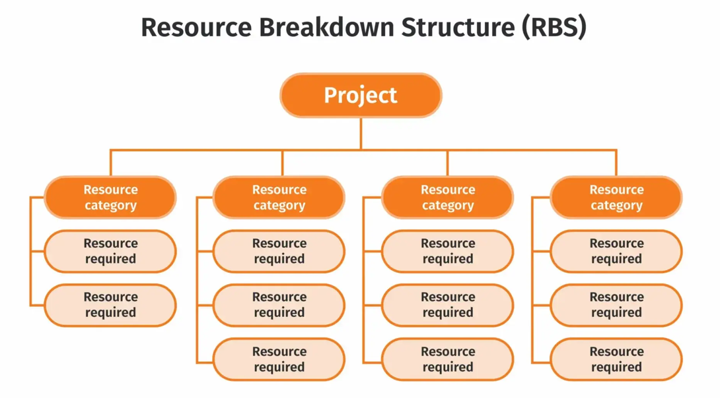
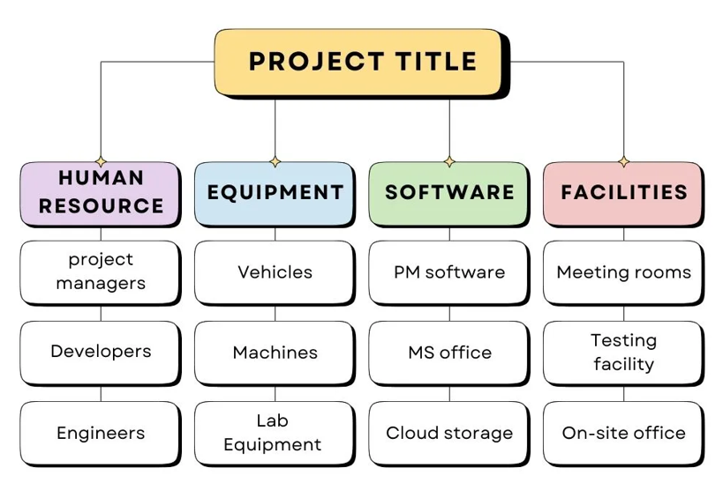

RACI Chart:
The RACI chart is a responsibility assignment matrix that clarifies roles and responsibilities in a project. It stands for:
- R: Responsible – the person who does the task.
- A: Accountable – the person ultimately answerable for the task's completion.
- C: Consulted – those whose opinions are sought for decisions.
- I: Informed – those kept in the loop but not involved in decision-making.
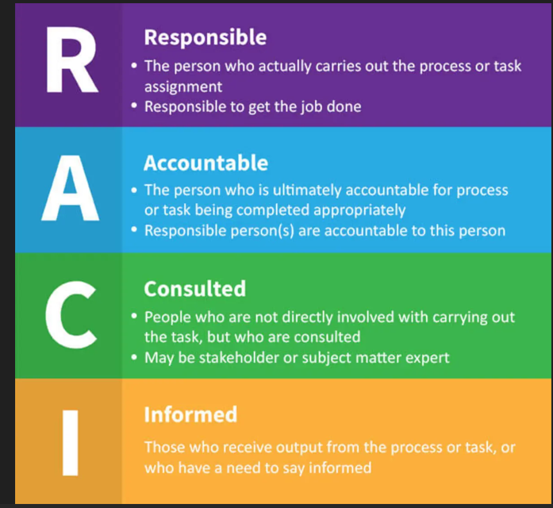
Below is an example of a RACI (Responsible, Accountable, Consulted, Informed) chart for the key tasks involved in developing an e-commerce website.
Task | Responsible (R) | Accountable (A) | Consulted (C) | Informed (I)
Define project scope and objectives | Project Manager | Business Owner | Development Team | All Team Members
Create website design (UI/UX) | UX/UI Designer | Project Manager | Graphic Designer | Business Owner
Develop frontend functionality | Frontend Developer | Project Manager | UX/UI Designer
Develop backend functionality | Backend Developer | Project Manager | Database Administrator
Perform quality assurance testing | QA Tester | QA Lead | Development Team | Project Manager
Implement website hosting | IT Support | Project Manager | Backend Developer | Business Owner
Launch website | Project Manager | Business Owner | Marketing Specialist | All Stakeholders
Monitor website post-launch | IT Support | Project Manager | Customer Support | Business Owner

